**Standard Operating Procedures:**

**Storing course assets**

**Analytics & Data Science Team**

**Prepared by:** Sushma Vegunta

sushmav@microsoft.com

**Date:**  3rd January 2017

**Sensitivity**: Confidential

# Contents

Contents 2

Document Properties 3

Distribution 3

References 3

Summary 4

Creating GitHub Repository for Storing Course Assets 5

Creating course assets and Folder structure in GitHub 6

Review / Update course assets to the recent version of product release 9

Publish the course 9

# Document Properties

|  |  |  |  |
| --- | --- | --- | --- |
| Date | Version | Description | Author |
| 01/03/2017 | 1.1 | Document created | Sushma Vegunta |
| 01/06/2017 | 1.2 | Revisions to the document to map to the development process | Chris Testa-O’Neill |
|  |  |  |  |
|  |  |  |  |

### Distribution

|  |  |  |  |  |
| --- | --- | --- | --- | --- |
| # | Area | Review & Sign-off | Review & Comment | Information Only |
| 1 | Managers | Kristin Tolle  Jeremy Reynolds |  | Judy Meyer |
| 2 | Project Managers | Sushma Vegunta | Pamela Watson | Marla Michaels |
| 3 | Trainers |  | Mithun Prasad  Buck Woody  Ryan Swanstrom  Micheleen Harris  Seth Mottaghinejad  Ali-Kazim Zaidi |  |
| 4 | Final sign-off | Kristin Tolle  Jeremy Reynolds |  | Sushma Vegunta  Pamela Watson  Marla Michaels  Ali-Kazim Zaidi  Seth Mottaghinejad  Micheleen Harris  Ryan Swanstrom  Buck Woody  Mithun Prasad |

### References

|  |  |  |
| --- | --- | --- |
| Document | Path | Description |
|  |  |  |
|  |  |  |
|  |  |  |
|  |  |  |

# Summary

This document defines the standard operating procedures for creating course in the course catalog that is hosted on the learnanalytics portal. This document is organized so that the contents can provide a link to the area of interest to the person performing the updates.

You will notice that as part of the development process, there are certain operations that should be performed by certain roles in the team, this is to aid the courseware development process and is summarized in the table below. In addition, the rights to publish and create new course will be locked down to PM and Managers only in the future

|  |  |  |
| --- | --- | --- |
| GitHub Activity | Role | Personnel |
| Create New GitHub Private Repository | Trainers/PM | Mithun Prasad  Buck Woody  Ryan Swanstrom  Micheleen Harris  Seth Mottaghinejad  Ali-Kazim Zaidi  Chris Testa-O’Neill  Sushma Vegunta |
| Creating course assets and Folder structure in GitHub | Trainers | Mithun Prasad  Buck Woody  Ryan Swanstrom  Micheleen Harris  Seth Mottaghinejad  Ali-Kazim Zaidi  Chris Testa-O’Neill |
| Review / Update course content to the recent version of product release | Trainers/PM/Manager | Mithun Prasad  Buck Woody  Ryan Swanstrom  Micheleen Harris  Seth Mottaghinejad  Ali-Kazim Zaidi  Chris Testa-O’Neill  Sushma Vegunta  Kristin Tolle  Jeremy Reynolds |
| Publishing the course – changing GitHub to public | Managers  PM’s | Kristin Tolle  Jeremy Reynolds  Sushma Vegunta |

# Creating GitHub Repository for Storing Course Assets

The following steps should be performed to create a GitHub Repository to store the course assets.

You need to be a member of Azure Organization before you can create repositories under Azure. The following two steps below only need to be performed once to gain access to the Azure Organization.

1. Enable the two-factor authentication for your GitHub account. More details on how to enable it are available at <https://github.com/blog/1614-two-factor-authentication>
2. Go to <http://aka.ms/azuregithub> to request to join the azure group.

To create Private GitHub repository, follow the steps given below(Done by the PM)

1. Login to <https://repos.opensource.microsoft.com/> using your Microsoft Credentials.
2. Select **Azure** from the list of Microsoft GitHub organizations as shown below

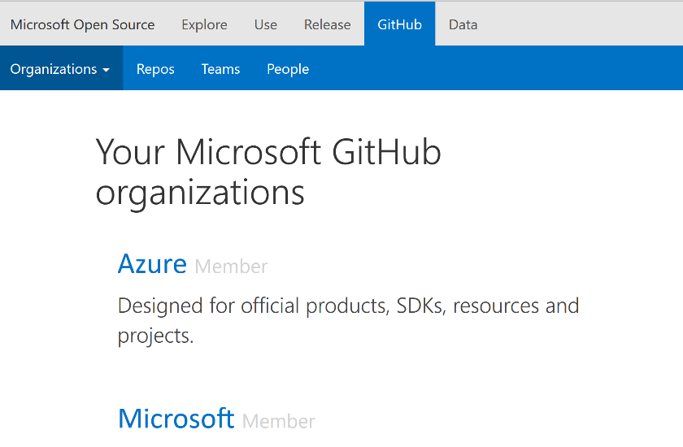

1. Click on **Create a Repo** from the options as shown below

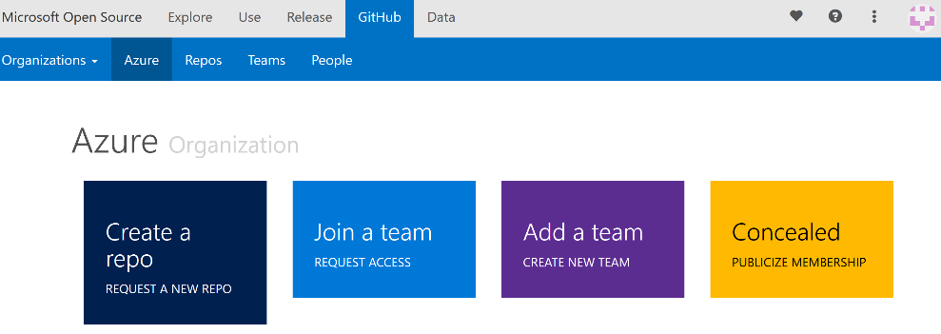

1. Fill in the details of the fields of the page as given below
   1. Name: Enter the name of the repo. The name of the GitHub repository should follow the following naming convention

learnanalytics-[technology]-[type of offering]

{Eg: learnanalytics-intelligentbot-instructorled}

* 1. Description: Enter a one line description of what this repository contains.
  2. License: Ensure that **MIT** is selected, which is the default.
  3. Approval Type: Select **OSS Business Approval Link** and in the text box paste in the following link: <https://osstool.microsoft.com/palamida/RequestDetails.htm?rid=45960&projectId=1&from=requests>
  4. Under Initial Visibility: Select the default which is **Private**
  5. Under Teams and Permissions: Under the Repo Admin Team select **learnAnalytics**
  6. Under Legal Entity: From the drop down select **No CLA**.
  7. Click **Submit** **request**.
  8. Once you click submit your private repository will be created and the page that loads contains the link to the new repository. An *email will be sent* to your Microsoft account about this information.

# **Creating course assets and Folder structure in GitHub**

1. Given below are the instructions on how to create folders and upload files to GitHub.
   1. Using GitHub Desktop Application
      1. Open GitHub Desktop Application
      2. Once the application loads click on symbol on the left side corner of the application. This will load the options available to Add, Create or Clone a repository. Click on **Clone** to clone the repository that the PM created for a course as instructed in the previous step.
      3. This will load all the organizations you are a member of as shown below

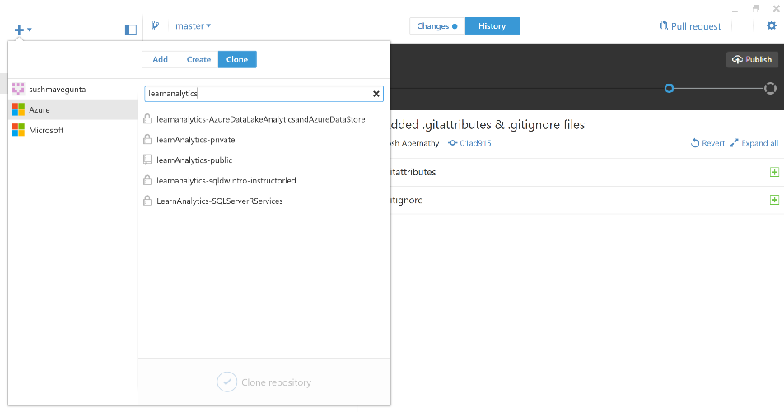

* + 1. You *may be* prompted to log into the Github, so that you can clone a repository. **Login**, and repeat step ii to display the repositories
    2. in the search box enter the name of the repository you created. Type **learnanalytics** and it will load all the repositories related to it.
    3. Double Click on the **repository** that you created and it loads the local directory structure, as shown in the following graphic.

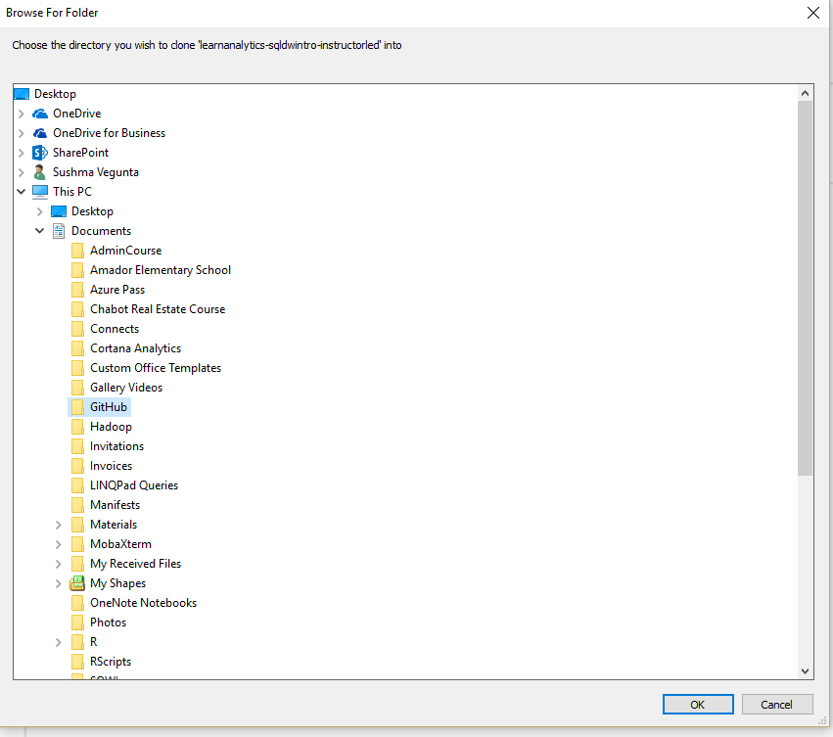

* + 1. Select the folder you want the GitHub repo to be cloned into and click **OK**
    2. Create the course assets as given below in Explorer and create the respective folders.

**Note:** If you create an empty folder the GitHub Application does not show you the changes automatically. Any folders that have files added to will appear as changes to the repository in the application. We do not create branches because of the complexity of data merging issues.

* + 1. Go back to the GitHub Desktop application to see all the additions you made to the folders as changes. Add a comment explaining what these changes are about and click **Commit to Master** as shown below.

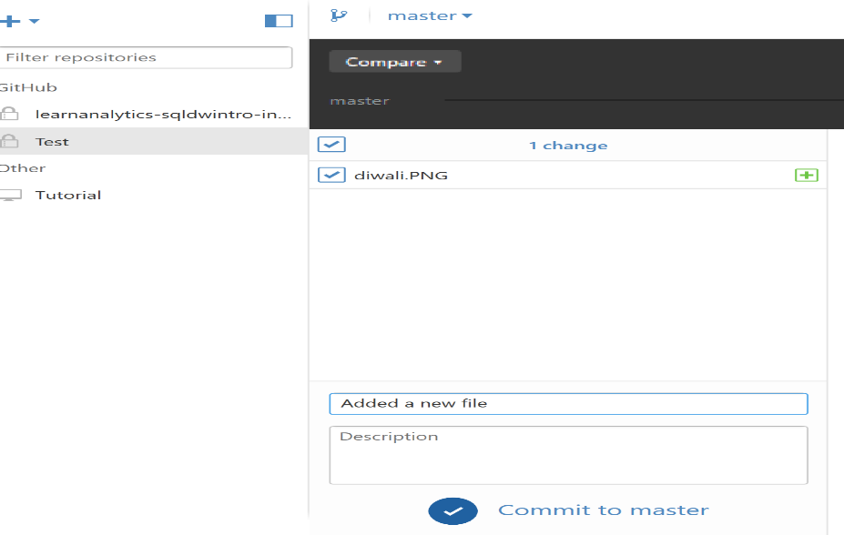

* + 1. Click **Publish** to synchronize the contents to the GitHub repository that you created in Azure.

1. Once a GitHub for a course has been created, authors should create the following folder using any one of the instruction given in 1 to create the structure as shown below

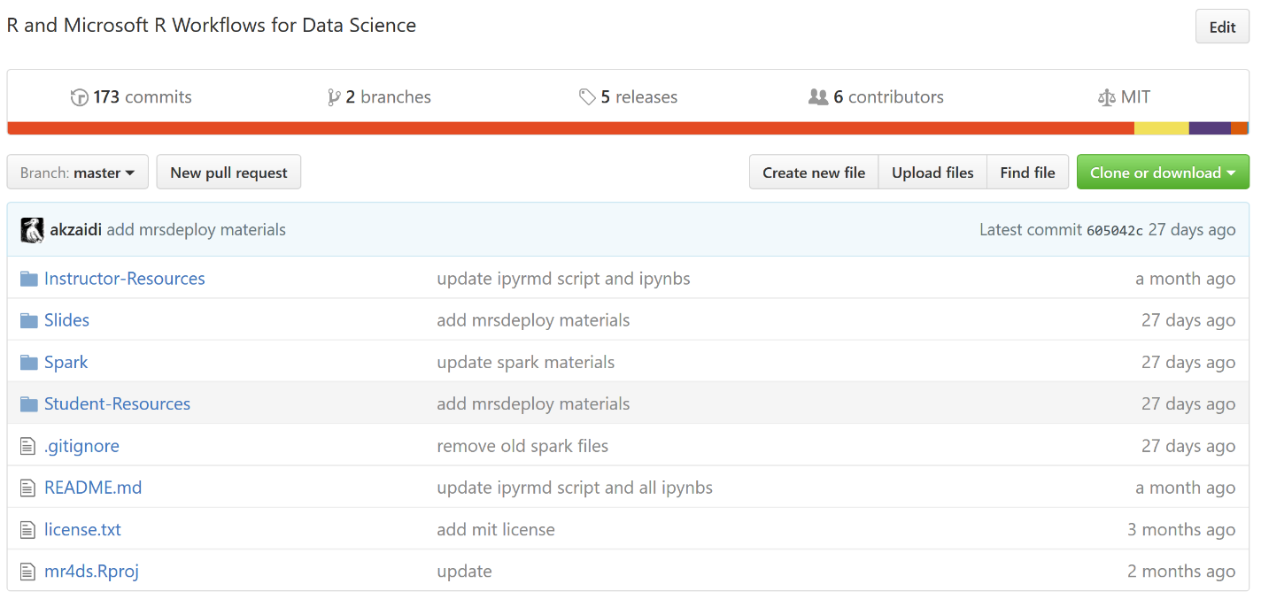

1. Given here are the instructions on what each folder in GitHub contains
   1. **Instructor-Resources**: This folder contains all the files that the instructor needs for instruction during a training. The scripts, packages that need to be installed, and any necessary scripts for infrastructure setup.
   2. **Student-Resources:** This folder contains all the files that are needed for a student from Handouts, Labs, notebooks and rmarkdown. An example of the folder structure is given below

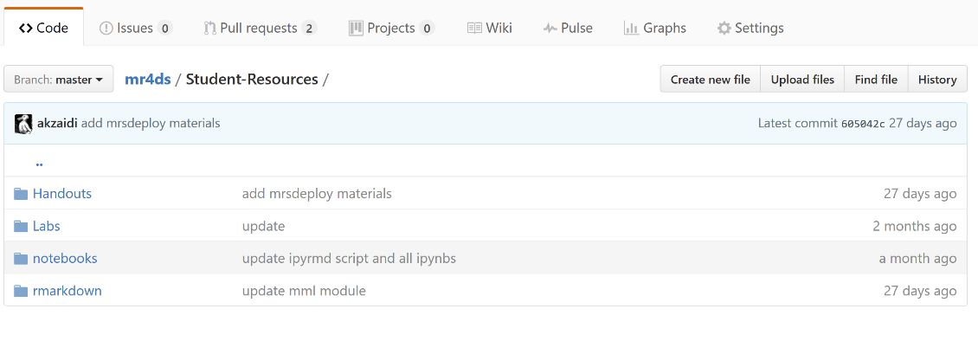

This folder contains all the handouts, labs and any additional documents required to learn about this course or in case of partners to re-use these to deliver trainings to customers.

1. Create a README.md file which contains all the instructions on how to navigate the folders structure that we created in GitHub to access and use the materials. An example of this is given in the link here <https://github.com/Azure/mr4ds/blob/master/README.md>

It should contain clear instructions on what this folder structure and how a new user can navigate and use the folder structure to use the course assets.

# Review / Update course assets to the recent version of product release

Review the course assets. Once the course assets have been created a note is sent to the PM team announcing the course is ready for review. The PM/Manager will assign a peer author for course asset review before release. The reviewer will provide feedback about the course assets and the author needs to make sure all the instructions given and the folder structure complies with the instructions as defined in this document.

Update course assets to the recent version of product release

* 1. Whenever there is a new version of product release the author needs to make sure that the course assets reflect the changes in the product to the course materials so we use the most recent versions of product for teaching.
  2. Update the course folders, scripts and the necessary files with the changes or updates reflecting the product release.
  3. Commit the changes with descriptions and Publish the course to Azure.

# Publish the course

* + 1. The PM would need to publish the course materials once they have been reviewed. Follow the instructions given below to publish
    2. Follow the link to the course repository and click on **Settings.** Scroll down to the bottom of the page to find options to make a repository public as shown below

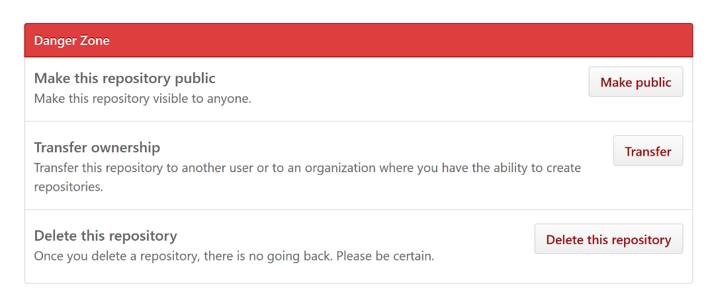

* + 1. Click on **Make public** to change a repository to be public. This makes the course in published state.